Demographic, Lifestyle, and Clinical
Correlates of Hypertension
A Survey-Weighted Cross-Sectional Analysis of NHANES 2017–March 2020
Manpreet • R (survey, gtsummary, ggplot2) • Pre-pandemic combined cycle

Research Question
How does hypertension relate to demographic (age, sex, race/ethnicity, education, income), lifestyle (BMI, physical activity, smoking, alcohol), and clinical (diabetes, total cholesterol) factors among U.S. adults — and does dietary sodium intake add independent explanatory value once those core risk factors are accounted for?

Why a Survey-Weighted Analysis, Not a Machine-Learning Pipeline
NHANES is not a simple random sample — it is a multi-stage, stratified, clustered probability sample with oversampling of some subgroups. Treating its rows as i.i.d. observations produces biased point estimates and badly wrong standard errors. This project uses the survey package throughout: every prevalence estimate, model coefficient, and confidence interval is computed from a svydesign object incorporating the sample weights (WTMECPRP / WTDRD1PP) and the masked-variance PSU/strata variables (SDMVPSU, SDMVSTRA) CDC provides specifically for this purpose.
The goal throughout is inference — which factors are associated with hypertension, how strongly, with defensible uncertainty — rather than prediction accuracy. There is no train/test split and no “accuracy” metric anywhere in this project, deliberately.

Data
Source: NHANES 2017–March 2020 pre-pandemic combined cycle, CDC's special replacement for the COVID-interrupted 2019-2020 collection, with its own purpose-built weights and masked-variance design variables.
- Ten linked NHANES modules merged on SEQN: demographics, oscillometric blood pressure exam, hypertension diagnosis/medication, body measures, physical activity, smoking, alcohol, diabetes, total cholesterol, and Day-1 dietary recall.
- Outcome defined two ways for a built-in sensitivity check: ACC/AHA 2017 (mean SBP ≥130 or DBP ≥80, or on antihypertensive medication — primary definition) and the older, more conservative JNC7 threshold (≥140/90).
- Analytic domain: adults (18+) who completed both the interview and the MEC exam, with a valid outcome — 8,293 sampled adults, representing an estimated 231.8 million U.S. adults after weighting.

Table 1. Weighted Baseline Characteristics
All percentages and means are survey-weighted, estimating the U.S. adult population rather than just the people sampled; p-values use design-based tests (Rao & Scott adjusted Pearson chi-squared, design-based Kruskal-Wallis), not naive unweighted tests.
Characteristic | Overall  N=231,774,165 | No HTN  N=118,798,473 | HTN  N=112,975,692 | p-value
age, mean (SD) | 48 (18) | 40 (16) | 56 (16) | <0.001
Sex |  |  |  | 0.001
Male | 112,725,754 (49%) | 54,456,820 (46%) | 58,268,934 (52%)
Female | 119,048,411 (51%) | 64,341,652 (54%) | 54,706,759 (48%)
Race/ethnicity |  |  |  | <0.001
Non-Hispanic White | 146,944,317 (63%) | 75,074,402 (63%) | 71,869,915 (64%)
Non-Hispanic Black | 26,412,175 (11%) | 10,943,882 (9.2%) | 15,468,294 (14%)
Mexican American | 18,724,667 (8.1%) | 11,721,454 (9.9%) | 7,003,212 (6.2%)
Other Hispanic | 17,268,591 (7.5%) | 9,564,482 (8.1%) | 7,704,109 (6.8%)
Non-Hispanic Asian | 12,936,574 (5.6%) | 6,955,490 (5.9%) | 5,981,085 (5.3%)
Other/Multi-racial | 9,487,841 (4.1%) | 4,538,763 (3.8%) | 4,949,078 (4.4%)
Education |  |  |  | <0.001
Less than 9th grade | 7,698,677 (3.4%) | 3,155,020 (2.8%) | 4,543,657 (4.0%)
9-11th grade | 15,856,093 (7.1%) | 6,733,592 (6.0%) | 9,122,501 (8.1%)
High school grad/GED | 61,409,806 (27%) | 27,441,037 (24%) | 33,968,769 (30%)
Some college/AA | 68,848,873 (31%) | 33,284,700 (30%) | 35,564,173 (32%)
College graduate+ | 71,068,870 (32%) | 41,853,273 (37%) | 29,215,597 (26%)
Income-to-poverty ratio, mean (SD) | 3.12 (1.64) | 3.12 (1.68) | 3.11 (1.61) | 0.8
BMI category |  |  |  | <0.001
Normal | 58,198,288 (25%) | 40,038,413 (34%) | 18,159,875 (16%)
Underweight | 3,331,577 (1.5%) | 2,607,346 (2.2%) | 724,231 (0.7%)
Overweight | 71,990,945 (31%) | 38,145,597 (32%) | 33,845,348 (30%)
Obese | 96,043,908 (42%) | 37,541,693 (32%) | 58,502,215 (53%)
Smoking |  |  |  | <0.001
Never | 134,652,535 (58%) | 74,786,580 (63%) | 59,865,955 (53%)
Former | 58,784,899 (25%) | 24,714,343 (21%) | 34,070,556 (30%)
Current | 38,273,056 (17%) | 19,280,126 (16%) | 18,992,930 (17%)
Alcohol use |  |  |  | <0.001
None (past year) | 35,927,032 (17%) | 13,916,731 (13%) | 22,010,301 (22%)
Moderate | 155,451,690 (75%) | 86,587,322 (81%) | 68,864,367 (68%)
Heavy | 16,591,136 (8.0%) | 6,913,581 (6.4%) | 9,677,554 (9.6%)
Diabetes | 27,164,692 (12%) | 5,034,621 (4.3%) | 22,130,071 (20%) | <0.001
Total cholesterol, mg/dL, mean (SD) | 187 (41) | 183 (40) | 190 (42) | <0.001
Meets PA guidelines | 158,033,583 (68%) | 89,260,047 (75%) | 68,773,536 (61%) | <0.001

Descriptive Epidemiology
Overall weighted hypertension prevalence (ACC/AHA 2017 definition) is 48.7% (SE 1.2 pp) — 51.7% among men vs. 46.0% among women, and highest among Non-Hispanic Black adults (58.6%) vs. Non-Hispanic White (48.9%) and Mexican American (37.4%) adults.
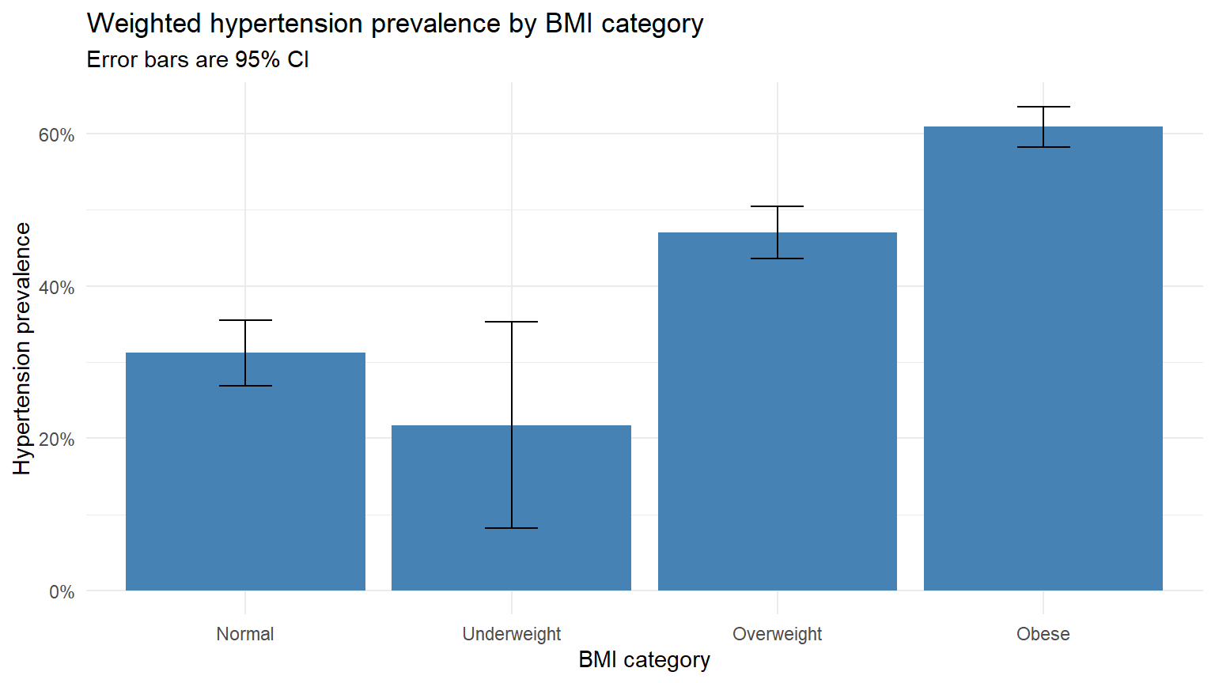
Figure 1. Weighted hypertension prevalence by BMI category, with 95% CI.
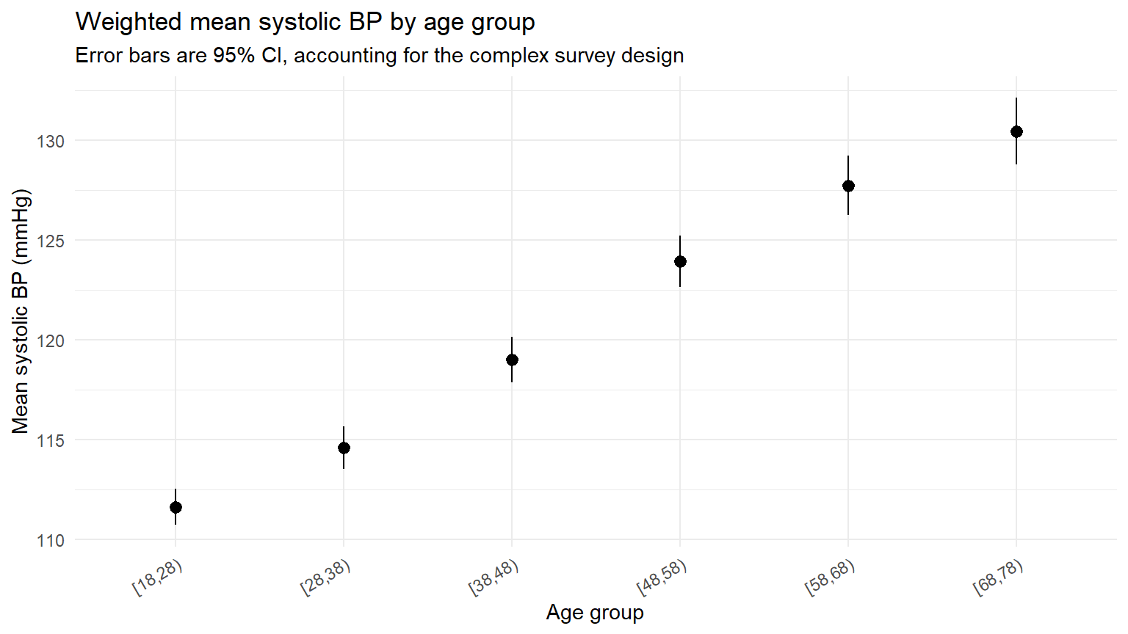
Figure 2. Weighted mean systolic blood pressure by age group, with 95% CI.

Adjusted Model Results
A survey-weighted multivariable logistic model (svyglm, quasibinomial family) adjusting for age, sex, race/ethnicity, education, income-to-poverty ratio, BMI category, smoking, alcohol use, diabetes, total cholesterol, and physical activity guideline compliance. The table below highlights the predictors with the clearest evidence of an association; the full 22-term model is in the accompanying analysis.Rmd / analysis.html.
Predictor (adjusted model) | Odds ratio | 95% CI | p-value
Obese (vs. normal BMI) | 3.25 | 2.29 - 4.62 | 0.002
Diabetes | 2.46 | 1.46 - 4.15 | 0.012
Heavy alcohol use | 2.14 | 1.15 - 3.99 | 0.030
Non-Hispanic Black (vs. White) | 2.08 | 1.28 - 3.40 | 0.018
Non-Hispanic Asian (vs. White) | 1.83 | 1.08 - 3.09 | 0.035
Overweight (vs. normal BMI) | 1.53 | 0.92 - 2.54 | 0.076
Age (per year) | 1.06 | 1.05 - 1.07 | <0.001
Total cholesterol (per mg/dL) | 1.003 | 1.000 - 1.006 | 0.038
Female sex | 0.64 | 0.41 - 1.01 | 0.053
Meets physical activity guidelines | 0.74 | 0.55 - 0.99 | 0.047
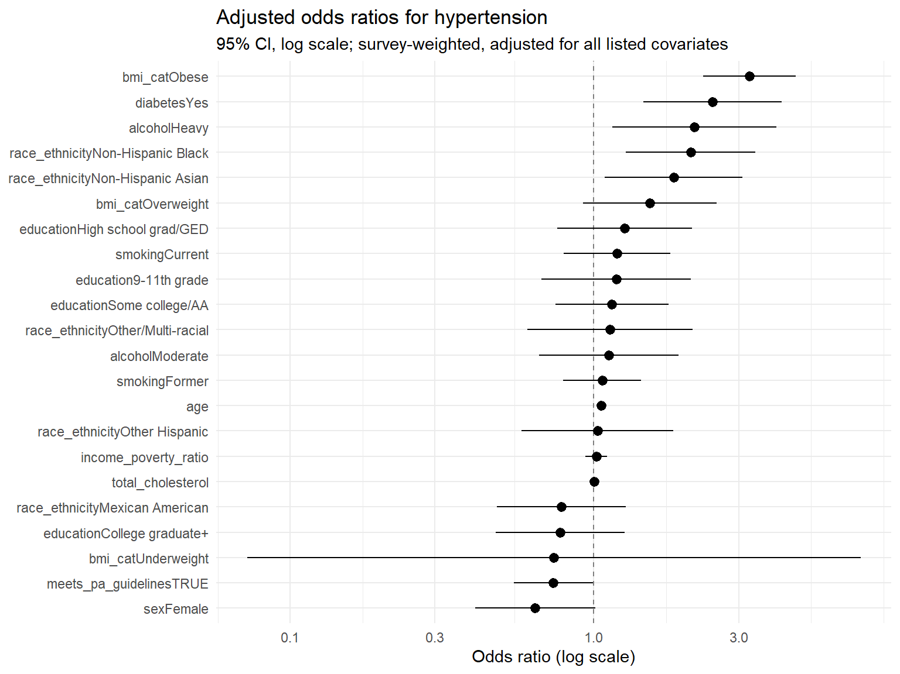
Figure 3. Adjusted odds ratios for hypertension, 95% CI, log scale (all 22 model terms).

Model Diagnostics
Multicollinearity was checked with generalized variance inflation factors (car::vif) — all GVIF^(1/(2·Df)) values were below 4.7, indicating no problematic collinearity among predictors. Linearity of the continuous age term was checked via a restricted cubic spline and a survey-adjusted Wald test (regTermTest); the test did not reach significance (p = 0.078), though on only 1 denominator degree of freedom — see Limitations. Calibration was assessed by comparing weighted mean predicted probability to weighted observed prevalence across deciles of predicted risk, restricted to the complete-case sample the model was fit on.
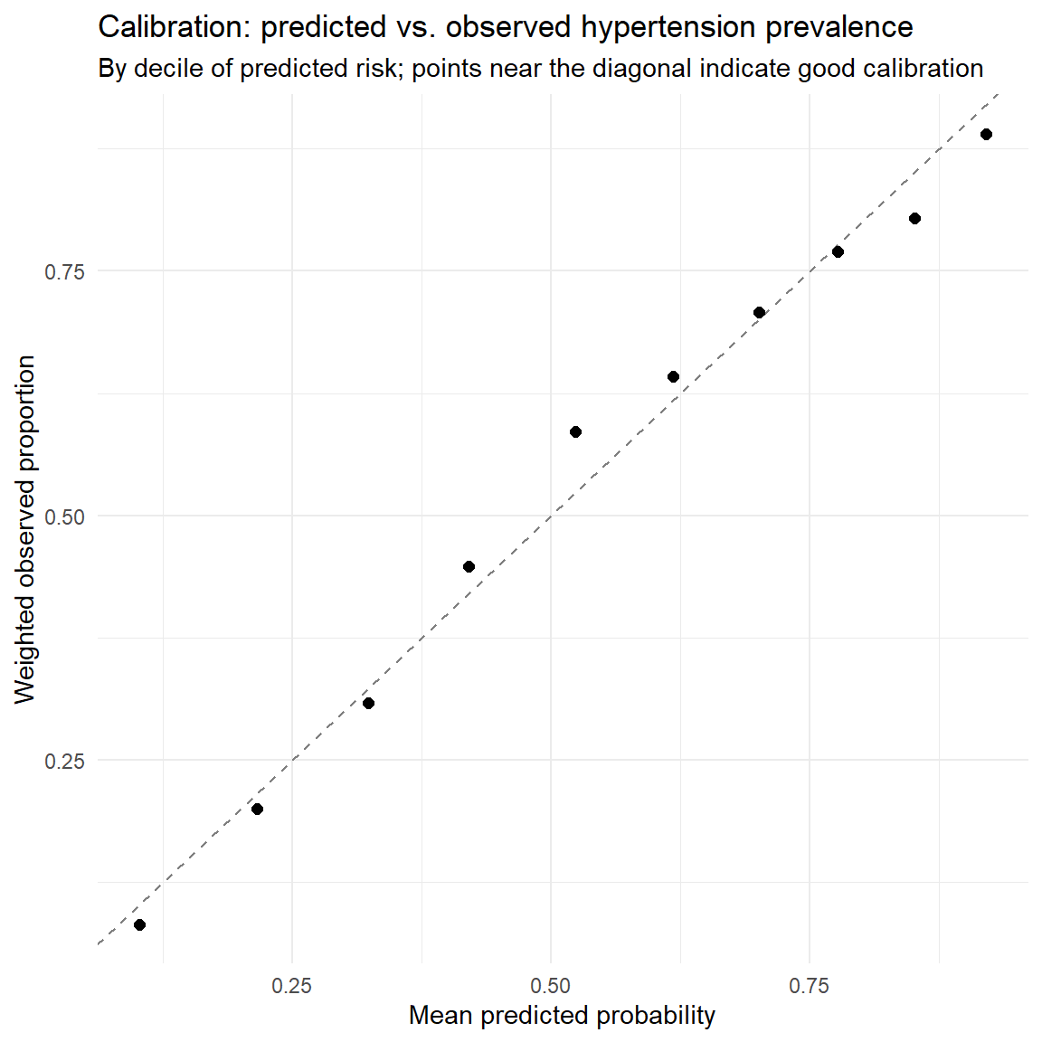
Figure 4. Calibration: predicted vs. observed hypertension prevalence by decile of predicted risk.

Sensitivity Analyses
Four checks probe whether the core conclusions are robust to specific analytic choices, rather than assuming they are.
Check | Finding
Alternative outcome definition (JNC7 vs. ACC/AHA 2017) | Same predictors, same direction of effect (e.g., obesity OR 3.25 under ACC/AHA 2017 vs. 2.78 under JNC7) -- conclusions do not depend on which BP threshold is used.
Excluding already-treated adults | Age (OR 1.03) and sex (OR 0.59) associations persist in the untreated-only subgroup, confirming these are not artifacts of who receives treatment.
Survey-weighted vs. naive (unweighted) model | Point estimates are similar, but the naive model's CIs are consistently narrower (e.g., age p = 8.3x10⁻¹⁴⁶ naive vs. p = 5.8x10⁻⁴ design-based) -- concrete evidence that ignoring NHANES's clustering/weighting overstates precision.
Dietary sodium (Day-1 recall subsample) | No significant independent association (sodium p = 0.78; energy p = 0.77) once core risk factors are in the model -- read as “no signal detected,” not “sodium doesn't matter,” given the noise in a single day's recall.

Interpretation
Obesity, diabetes, heavy alcohol use, and age are the strongest independent predictors of hypertension in this sample, with obesity showing the single largest effect size (OR 3.25, 95% CI 2.29–4.62) — consistent with the well-established obesity-hypertension literature and the visible gradient in Figure 1. Meeting physical activity guidelines is independently protective (OR 0.74, 95% CI 0.55–0.99). Race/ethnicity disparities are evident and persist after adjustment: Non-Hispanic Black adults have roughly double the odds of hypertension of Non-Hispanic White adults (OR 2.08, 95% CI 1.28–3.40) even after accounting for age, BMI, income, and the other covariates in the model — pointing to factors beyond those measured here (e.g., chronic stress, access to care, structural factors) as worth further investigation.
Dietary sodium showed no significant independent association with hypertension once core risk factors were already in the model. This should be read as “no signal detected in this data,” not as evidence that sodium is unimportant — a single day's dietary recall is a genuinely noisy proxy for usual intake, one of this analysis's clearest limitations.
The side-by-side weighted-vs-naive comparison makes the survey-design point concrete rather than asserted: point estimates are similar between the two approaches, but the naive (unweighted, i.i.d.) model's confidence intervals are consistently narrower and its p-values far smaller — exactly the overconfident precision that ignoring NHANES's clustering and weighting would otherwise produce.

Limitations
- Cross-sectional design — no temporal ordering; associations cannot establish causal direction (e.g., whether inactivity causes hypertension or hypertension-related symptoms reduce activity).
- Design degrees of freedom are very low after domain-subsetting: several Wald-type tests (e.g., the age-linearity spline test, F on 3 and 1 denominator df) have only a handful of denominator degrees of freedom once the design is subset to the adult/valid-outcome domain — a real constraint on precision for this specific pre-pandemic combined cycle, visible in how much wider several adjusted CIs are than their naive-model counterparts.
- Self-reported smoking, alcohol, and diabetes status are subject to social-desirability and recall bias.
- A single day's dietary recall is a noisy proxy for usual sodium intake — the classic nutritional-epidemiology caveat, and the reason the null diet finding is read cautiously.
- Complete-case handling of income-to-poverty-ratio missingness assumes the data are missing at random (MAR).

Next Steps
- Multiple imputation combined with survey's replicate-weight machinery (mitools + survey) as a robustness check on the missingness assumption.
- A restricted cubic spline on total cholesterol, and stratified models by sex or age group if effect modification is suspected.
- Given how few design degrees of freedom remain after subsetting, check whether an alternative variance estimator (e.g., balanced repeated replication weights, if released for this cycle) narrows the adjusted CIs meaningfully.

Methods Summary
- Merge ten NHANES modules on SEQN; derive the outcome and every lifestyle/clinical predictor with documented derivation logic (raw, untranslated NHANES codes throughout — see Data Notes).
- Build the survey design on the full sample first, then subset() down to the analytic domain — preserving correct variance estimation, unlike filtering the raw data frame before designing.
- Weighted Table 1, weighted prevalence estimates, weighted exploratory analysis.
- Crude (unadjusted) and adjusted multivariable svyglm (quasibinomial) models; odds ratios with 95% CI; forest plot.
- Diagnostics: multicollinearity (car::vif), linearity of continuous predictors (spline term + survey-adjusted Wald test), and a weighted decile calibration table.
- Sensitivity analyses: alternate hypertension definition (JNC7), excluding already-treated participants, survey-weighted vs. naive unweighted model, and a diet-augmented model on the dietary-recall subsample using its own weight.

Data Notes
nhanesA::nhanes() defaults to translated = TRUE, which silently converts every coded NHANES variable (RIDSTATR, PAQ605, SMQ020, ALQ121, DIQ010, BPQ050A, DR1DRSTZ, etc.) from its documented numeric code into a labeled factor. Every derivation in this project is written against the raw numeric codebook, so the download step explicitly forces translated = FALSE to keep every variable as the plain numeric code CDC's documentation describes.

